The Next Step: Relationship Bootcamp
LOGIN USING THE WEEKLY MEETING LINK ON THE WEBSITE

I am so glad that you decided to join our first Relationship Bootcamp for Next Step Women Empowering Women. My intention for the workshop is to empower us all by equipping us with tools that in my own opinion, would have been great to have had before leaving high school. Bottomline is we could all use a refresher so we will begin with some basics and then work up towards our current place in our lives. The first module is all about the SELF, because it is the MOST important of all our relationships.

To better prepare for our meetings I will be providing you with pre session questions (and possibly other items) to be filled out before our meeting begins. We will review these together.

I also ask that you get a special journal for this workshop and a three-ring binder for the homework handouts I’ll be providing you with. The goal is for you to have a functional reference tool for your relationships to access in your life, to add to as you grow and learn more in your journey of recovery. I personally decorated mine in the program I was in, I made it like a vision board with words and images that resonated with me. Do whatever you like but the more personal you make it, the greater the impact it will have for you. I purchased the plastic sleeve sheet covers for inserting into my binder.

Please have these completed for our Module One Workshop 2/10/21 at 6pm - 8pm CST (weekly!!!) - I also ask that you consider allowing recordings of the workshop for use among us only...I would then be able to post them in the event you miss a meeting and can review the info. (vote on this will be done before starting the meeting on Wednesday)

Module One Pre-Session Questions:

- What makes you feel good about yourself?
- What have people in your life said or done to you that has made you feel good or bad about yourself?
- Have there been times in your life when you have felt better about yourself than in others? Why do you feel that is?
- To what extent does how you feel about yourself depend on another person’s opinion of you? How do you think being harmed (emotionally or physically) in past relationships or in present one affects your overall sense of self-esteem?
- Are there certain areas of your life about which you feel better than others? (relationships, work, family, etc.)

Please rate yourself on the following self-esteem thermometer. This is to help you see where you are…then use another color to mark where you WANT TO BE….and another to show where you think is REASONABLE to be by the end of the workshop.
(Higher = High Level Esteem / Lower = Low Level Esteem)
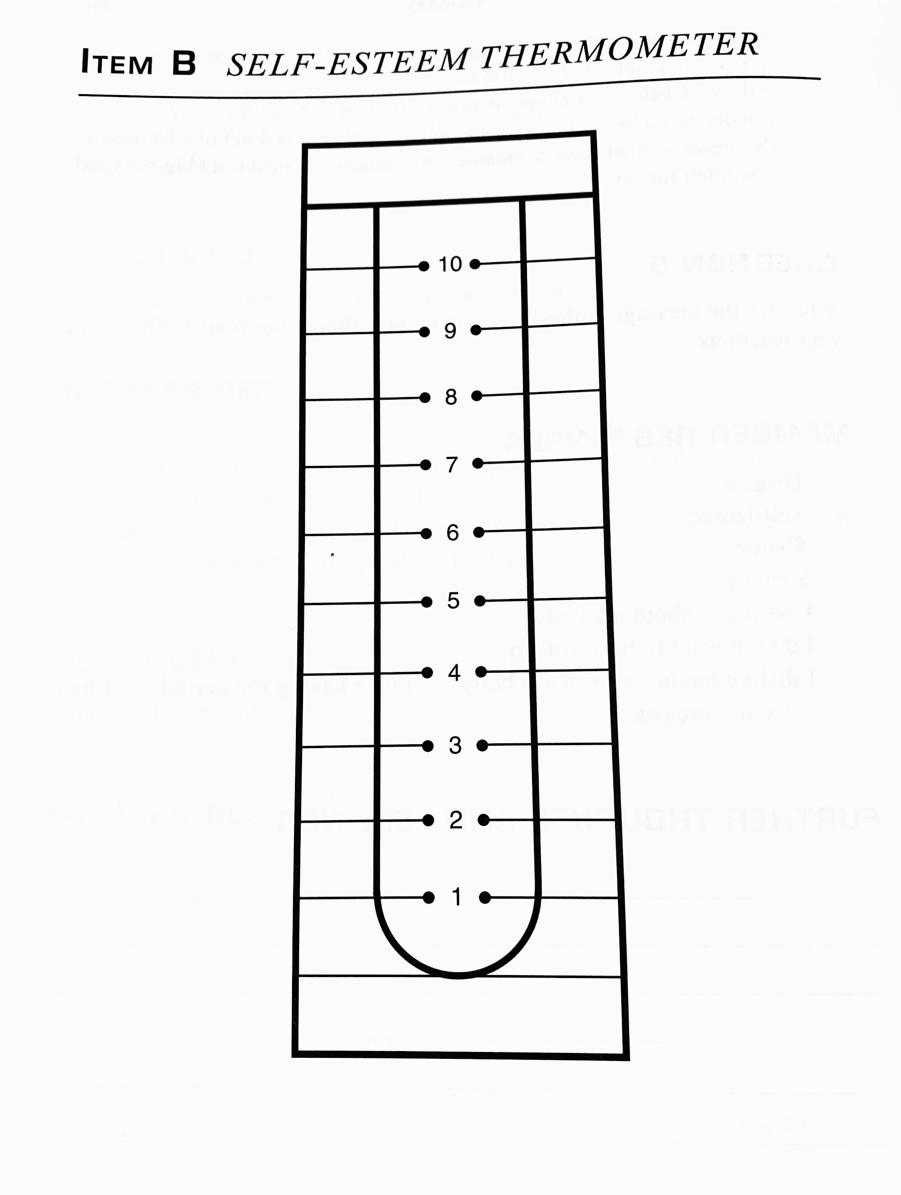

The Chart below is our Self Esteem Achievement Life Event Chart. Use this to gauge your personal self-esteem levels up to your current state of self-esteem. A blank chart will follow on the next page.

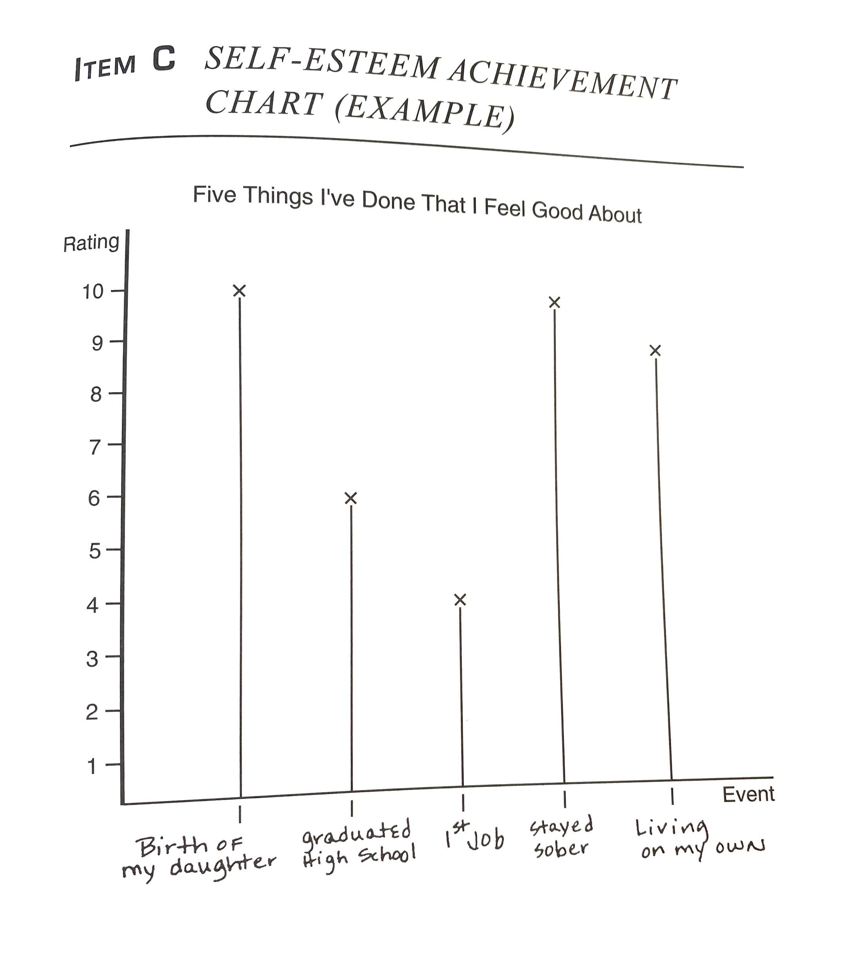
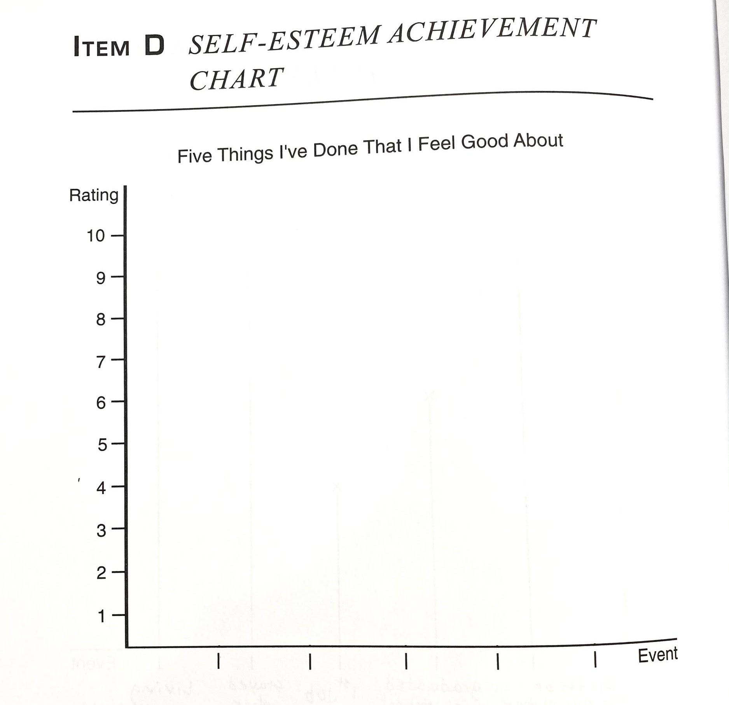

I am committing to showing up and providing you with these tools and skills while also sharing my experience, strength and hope to help you all avoid unnecessary pitfalls and to find hope that you CAN have a better life for yourself and attain the healthy relationship with yourself and with others that we all desperately desire to have. Most importantly, the healthy life and relationships we all DESERVE!

We are worth it, we can do the hard things, and we DO recover.

In Service,
Kimberly

